**AP Assignment no. 5**

**Name : Aditya Kr. Ishwar UID : 22BCS14310 Section : 605-B**

**Ques 1. Find the Difference (389)**

**Solution :- class Solution {**

**public:**

**char findTheDifference(string s, string t)**

**{**

**for(int i=0;i<s.size();i++)**

**t[i+1]+=t[i]-s[i];**

**return t[t.size()-1];**

**}**

**};**

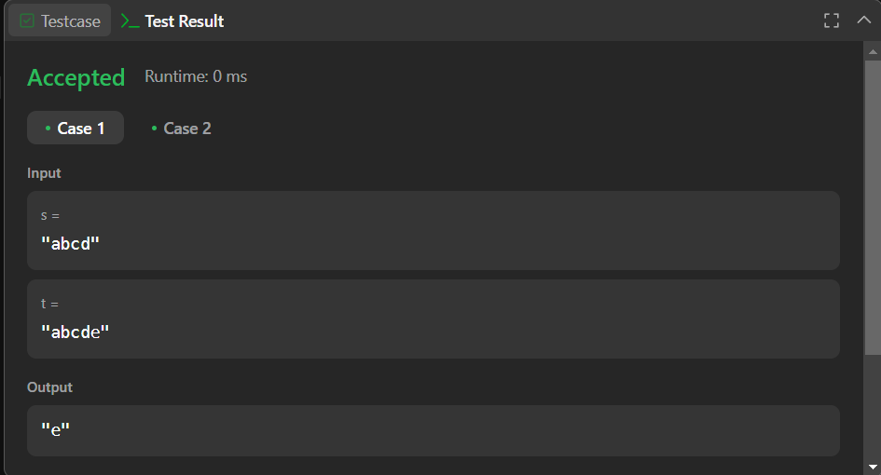

**Ques no. 2:- Largest Perimeter Triangle (976)**

**Solution :- class Solution {**

**public:**

**int largestPerimeter(vector<int>& nums) {**

**sort(nums.begin(),nums.end());**

**for(int i=nums.size()-1;i>1;i--){**

**if(nums[i]<nums[i-1]+nums[i-2])**

**return nums[i]+nums[i-1]+nums[i-2];**

**}**

**return 0;**

**}**

**};**

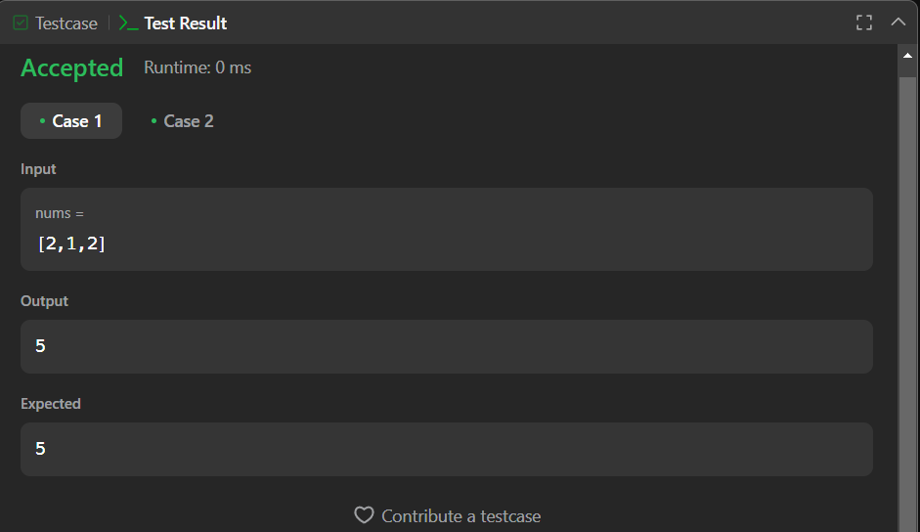

**Ques no.3:- Third Maximum Number(414)**

**Solution :- class Solution {**

**public:**

**int thirdMax(vector<int>& nums) {**

**long max = LONG_MIN, max2 = LONG_MIN, max3 = LONG_MIN;**

**for (int i = 0; i < nums.size(); i++) {**

**if (nums[i] == max || nums[i] == max2 || nums[i] == max3)**

**continue;**

**if (nums[i] > max) {**

**max3 = max2;**

**max2 = max;**

**max = nums[i];**

**} else if (nums[i] > max2 && nums[i] != max) {**

**max3 = max2;**

**max2 = nums[i];**

**} else if (nums[i] > max3 && nums[i] != max && nums[i] != max2) {**

**max3 = nums[i]; } }**

**if (nums.size() < 3) {**

**return max; }**

**return (max3 == LONG_MIN) ? max : max3;**

**} };**

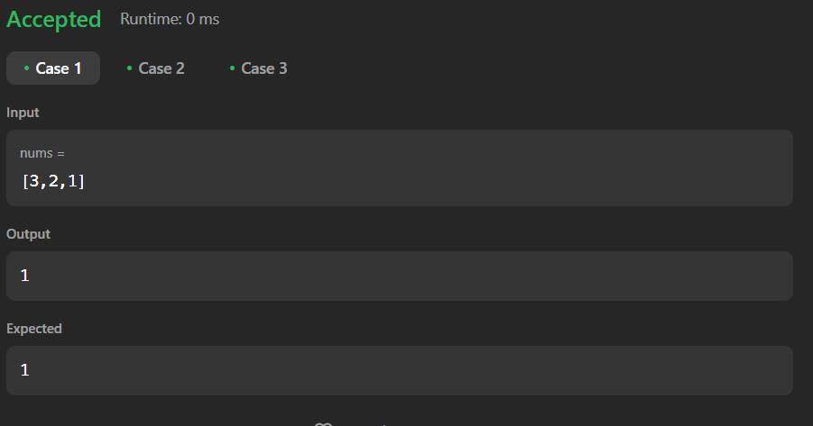

**Ques no. 4:- Sort Characters By Frequency(451)**

**Solution :-**

**class Solution {**

**public:**

**string frequencySort(string s) {**

**unordered_map<char,int> mp;**

**multimap<int,char> r;**

**string ss="";**

**for(auto a : s)**

**mp[a]++;**

**for(auto a : mp)**

**r.insert({a.second, a.first});**

**for(auto it = r.rbegin(); it != r.rend(); ++it)**

**ss += string(it->first, it->second);**

**return ss;**

**}**

**};**

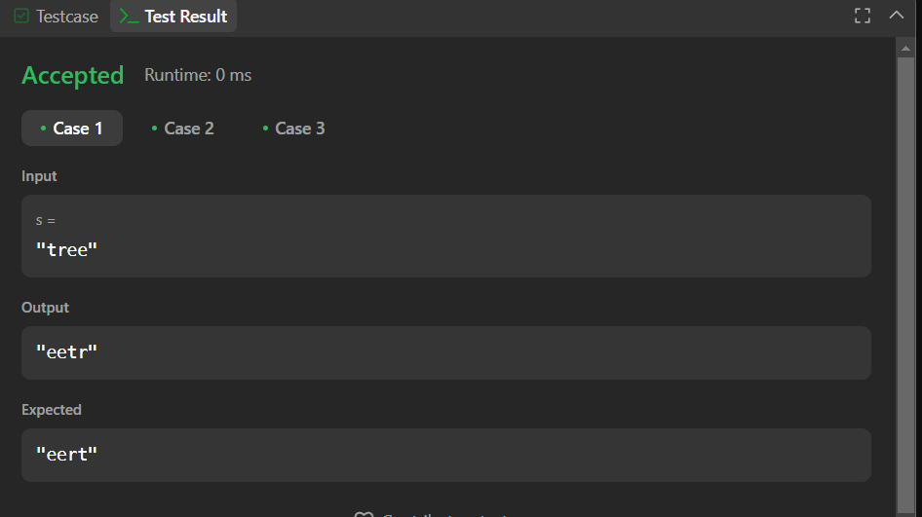

**Ques no.5:- Minimum Number of Arrows to Burst Balloons(452)**

**Solution :- class Solution {**

**public:**

**int findMinArrowShots(vector<vector<int>>& p) {**

**sort(p.begin(), p.end());**

**int lastpoint = p[0][1];**

**int ans = 1;**

**for(auto point : p) {**

**if(point[0] > lastpoint) {**

**ans++;**

**lastpoint = point[1];**

**}**

**lastpoint = min(point[1],lastpoint);**

**}**

**return ans;**

**}**

**};**

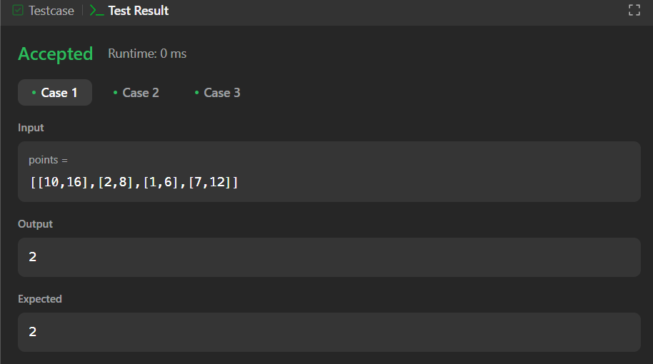

**Ques no. 6 :- Boats to Save People (881)**

**Solution :- class Solution {**

**public:**

**int numRescueBoats(vector<int>& people, int limit) {**

**sort(people.begin(),people.end());**

**int i = 0, j = people.size() - 1,cnt = 0;**

**while(i <= j)**

**{**

**if(people[i] + people[j] <= limit)**

**{**

**++i;**

**--j;**

**}**

**else**

**--j;**

**++cnt;**

**}**

**return cnt;**

**}**

**};**

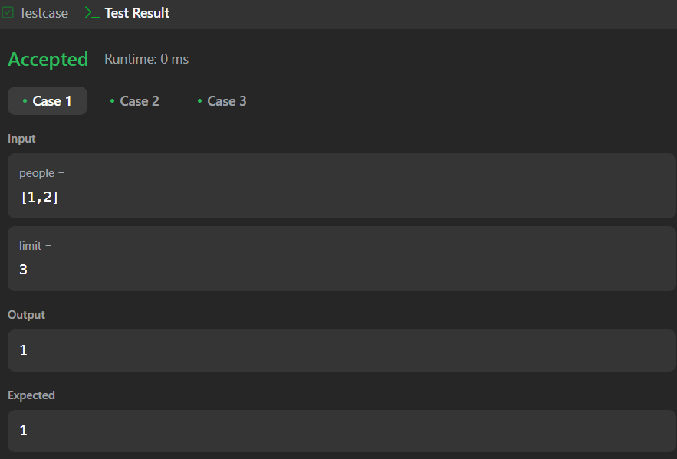

**Ques no. 7 :- K Closest Points to Origin (973)**

**Solution :- class Solution {**

**public:**

**vector<vector<int>> kClosest(vector<vector<int>>& points, int k) {**

**vector<pair<int,int>> a;**

**vector<vector<int>> ans;**

**for(int i=0;i<points.size();i++) a.push_back(make_pair(i,((points[i][0]*points[i][0])+(points[i][1]*points[i][1]))));**

**sort(a.begin(),a.end() ,[] (pair<int,int> x,pair<int,int> y){return x.second<y.second;});**

**for(auto i=a.begin();i<a.begin()+k;i++) ans.push_back(points[i->first]);**

**return ans;}};**

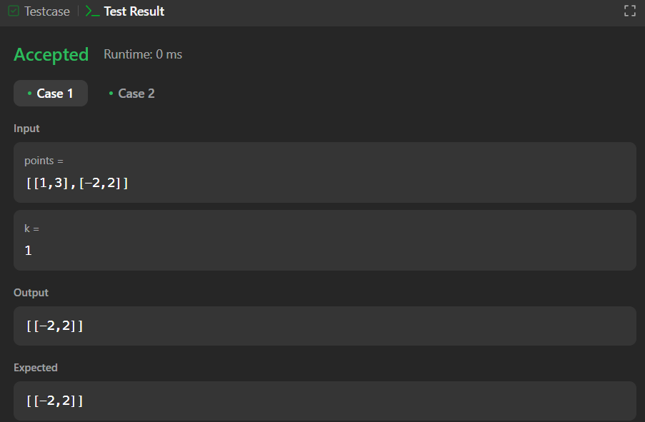

**Ques no. 8 :- Reduce Array Size to The Half(1338)**

**Solution :- class Solution {**

**public:**

**int minSetSize(vector<int>& arr) {**

**int n = arr.size();**

**unordered_map<int, int> cnt;**

**for (int x : arr) ++cnt[x];**

**vector<int> counting(n + 1);**

**for (auto [_, freq] : cnt) ++counting[freq];**

**int ans = 0, removed = 0, half = n / 2, freq = n;**

**while (removed < half) {**

**ans += 1;**

**while (counting[freq] == 0) --freq;**

**removed += freq;**

**--counting[freq];**

**}return ans;**

**} };**

